OS Deployment and Multicast

Setup
Installed a windows server and a ubuntu on my NUC.

Set static IP:
Ubuntu Server: 172.26.2.129
Windows Server: 172.26.2.130
Opensuse client: DHCP
Windows client: DHCP

Installing MDT and WDS
On windows server:

Prerequisites
- Install Windows ADK
- Install the PE add-on for ADK
- Install the WISM 1903 update

Install WDS
Powershell script to install:

Install-WindowsFeature -Name WDS -IncludeManagementTools

Install MDT
Can be found on Microsofts official site.
Run the MSI to install.

Configure WDS
Configure WDS through the server manager tools.
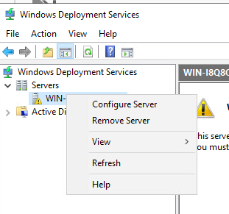
Select outside of Active directory because no Active Directory is configured.
Respond to all clients.
Add boot config and image config.

Install FOG
On the ubuntu server.

Clone the git repository: git clone https://github.com/FOGProject/fogproject.git
and run the installer: ./installfrog.sh

Set the DHCP server as the windows server.

Install DHCP server
DHCP server can easily be installed on the windows server through the manage -> roles and features tab.

Also set the DHCP scope from 172.26.2.135 to 172.26.2.140

Capture the image with FOG project
From vmware web interface, enable force BIOS setup.

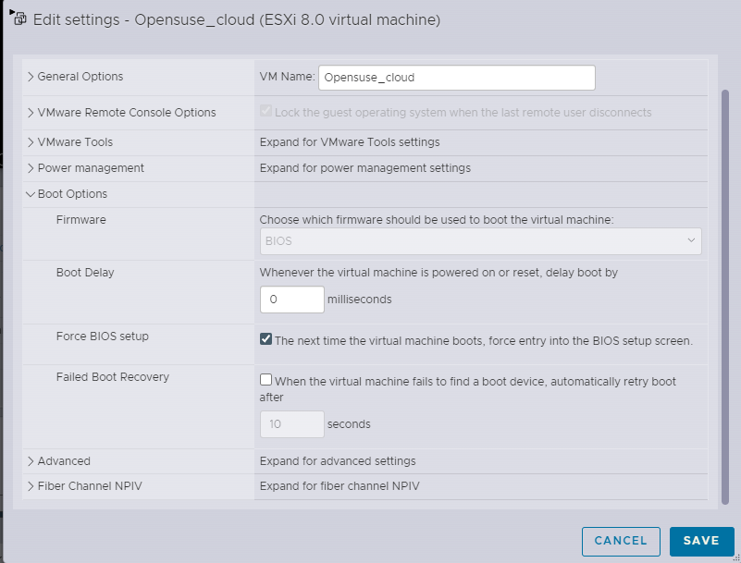
Then set network boot as the first option.
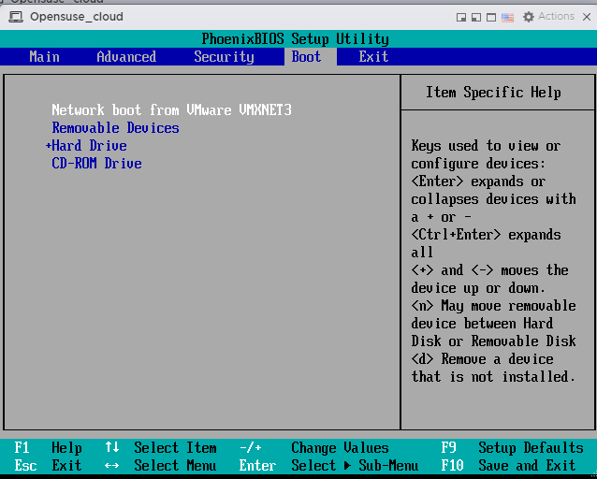
Enter the PXE-boot address:
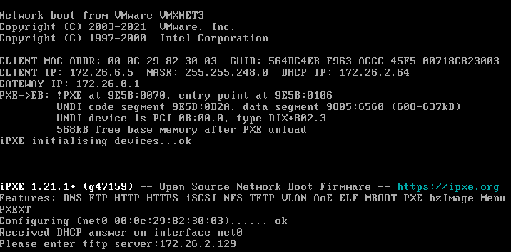
Then quick register and inventory the host:
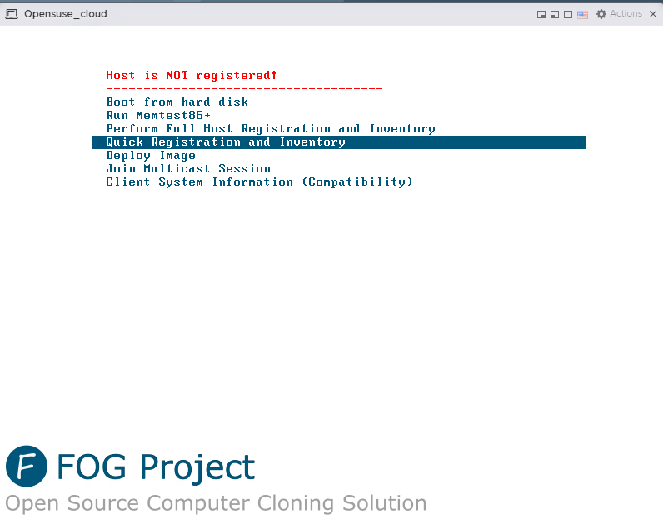
Then boot into fog again to capture the full image:
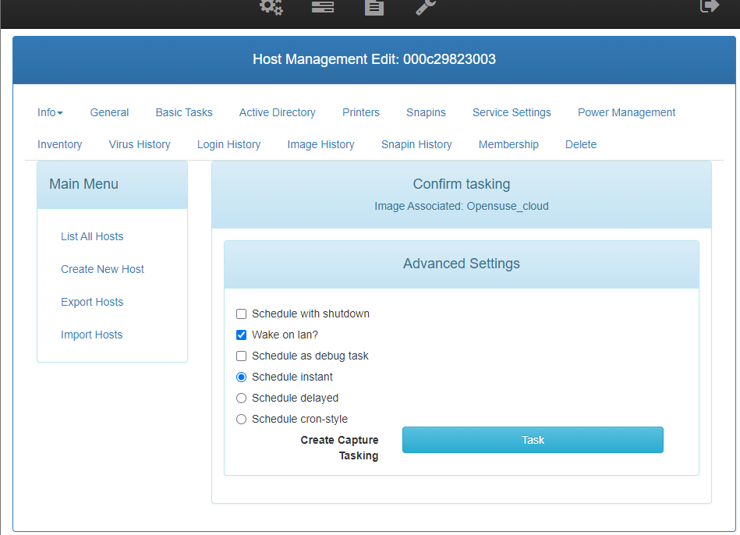
Then boot into the fog image again and it will clone the images:
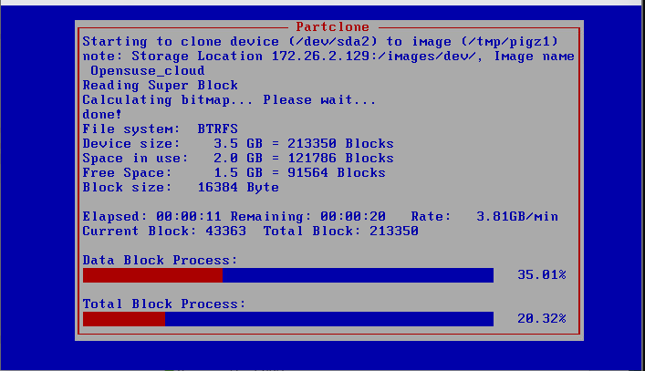

Deploy the desktop using FOG:
Boot into the FOG server again. And select the deploy image option:
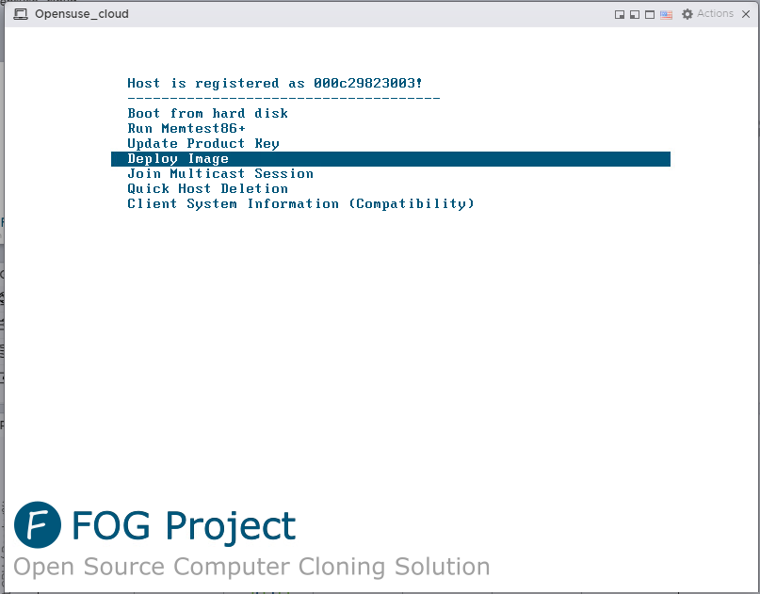
Select the fog project image.
This will clone the OS to the hard drive:
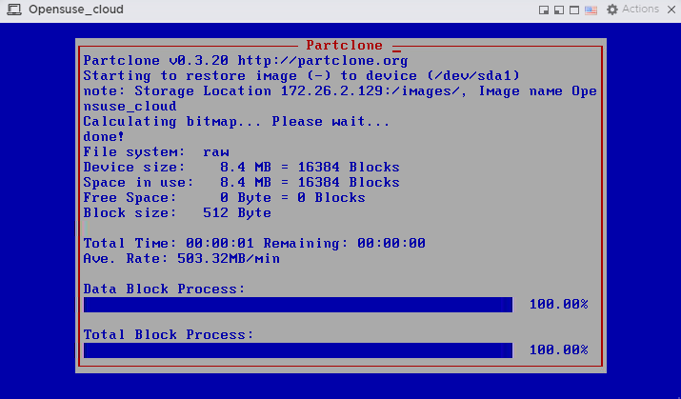

Deploy the image
Deploy an image to the host with the green arrow:
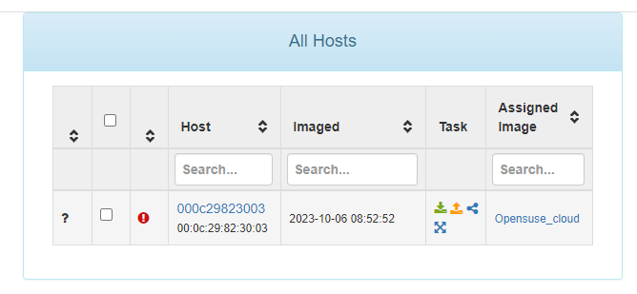
The associated image is automatically selected. Then select the wake on lan option:
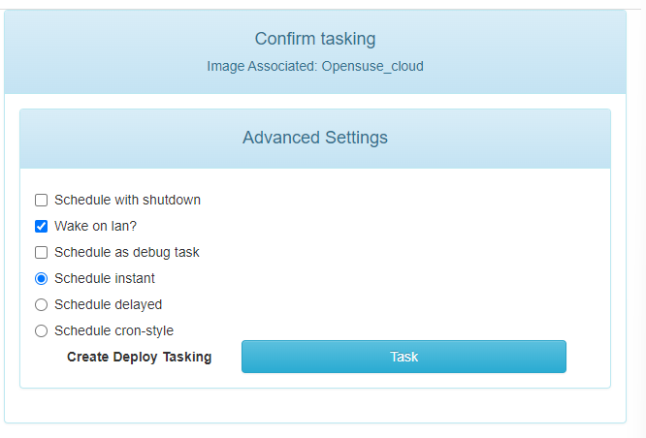
The deployment will then start automatically.

Using Microsoft deployment tools
Create a new deployment share with the MDT:
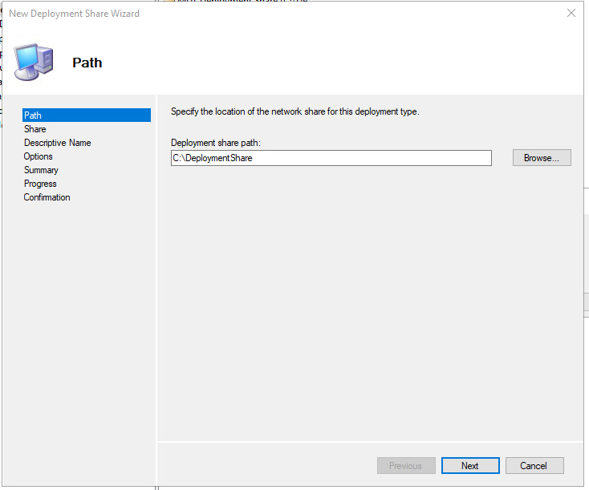

Importing OS
Add the OS to the deployment share:

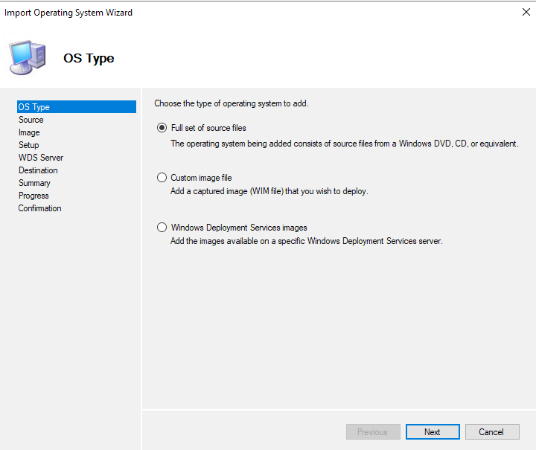
Creating the task sequence
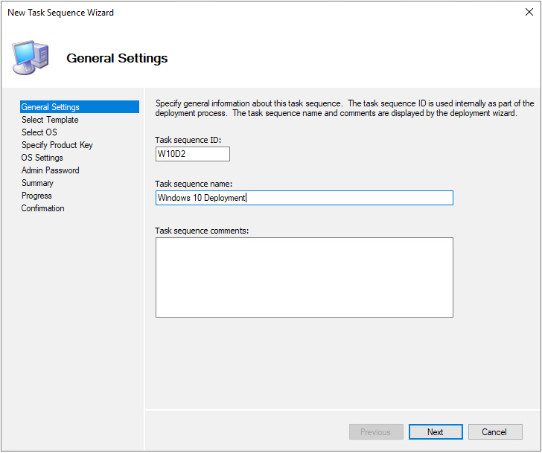

Update the deploymentshare
Disable x86 (not supported properly by windows 10)
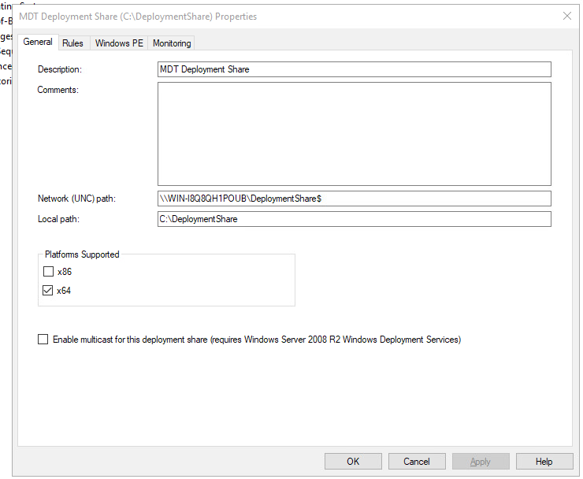
Update the deployment share:
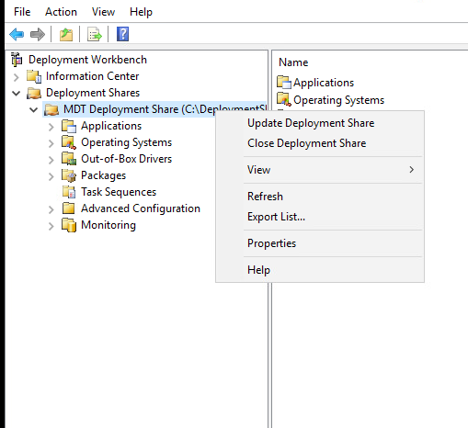

Windows deployment share:
In windows add a new boot image to the deployment server.
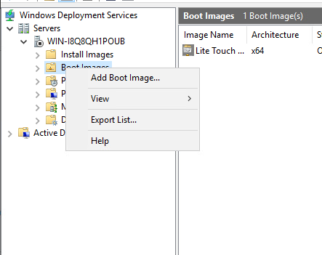
Select the boot image from the folder you created in deployment workbench.
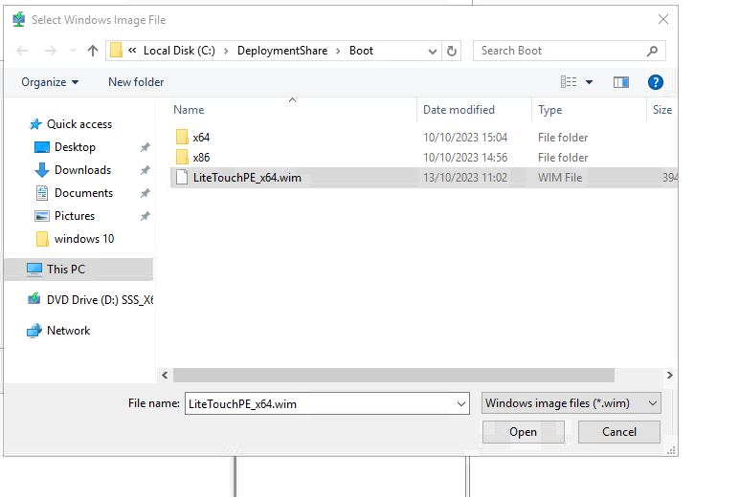
Now when PXE boot is active, you can boot to this image and it will install windows 10.

References:
https://learn.microsoft.com/en-us/windows/deployment/deploy-windows-mdt/prepare-for-windows-deployment-with-mdt#install-mdt

https://jgoedbloed-docstest.readthedocs.io/en/latest/installation/

